Dharshini M

Date:3/1/2024

Mail: [dharshini.m003@gmail.com](mailto:dharshini.m003@gmail.com)

Topic: Data Lake Storage Gen2

We should create a delta lake storage account using our resource group

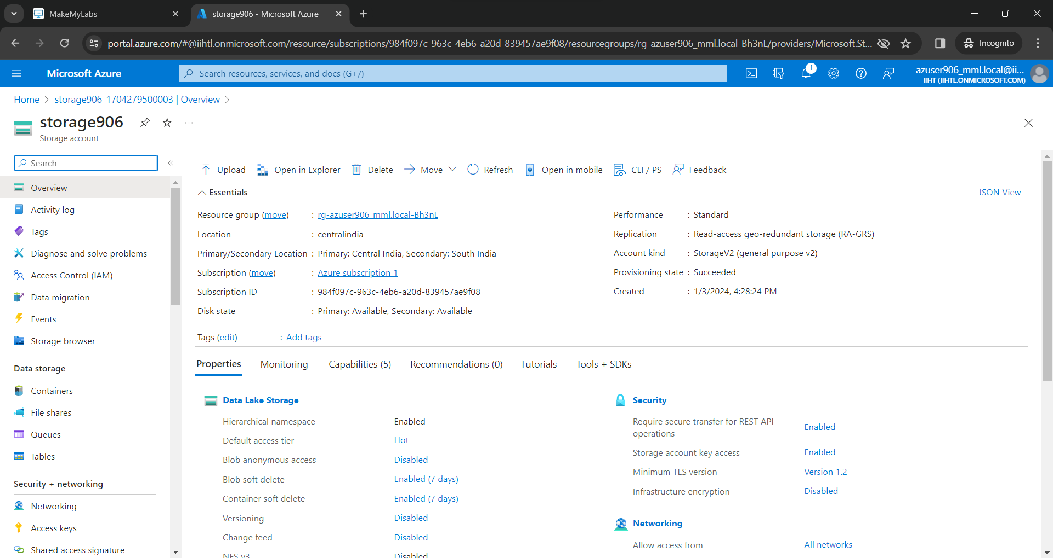

Then we should create a container

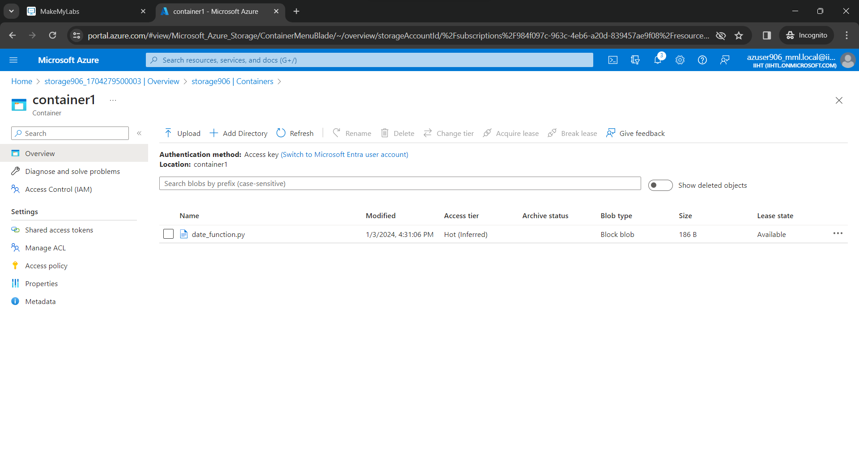

In the container we created, we can upload files and folders. It can we viewed in the browsr using the url we get after uploading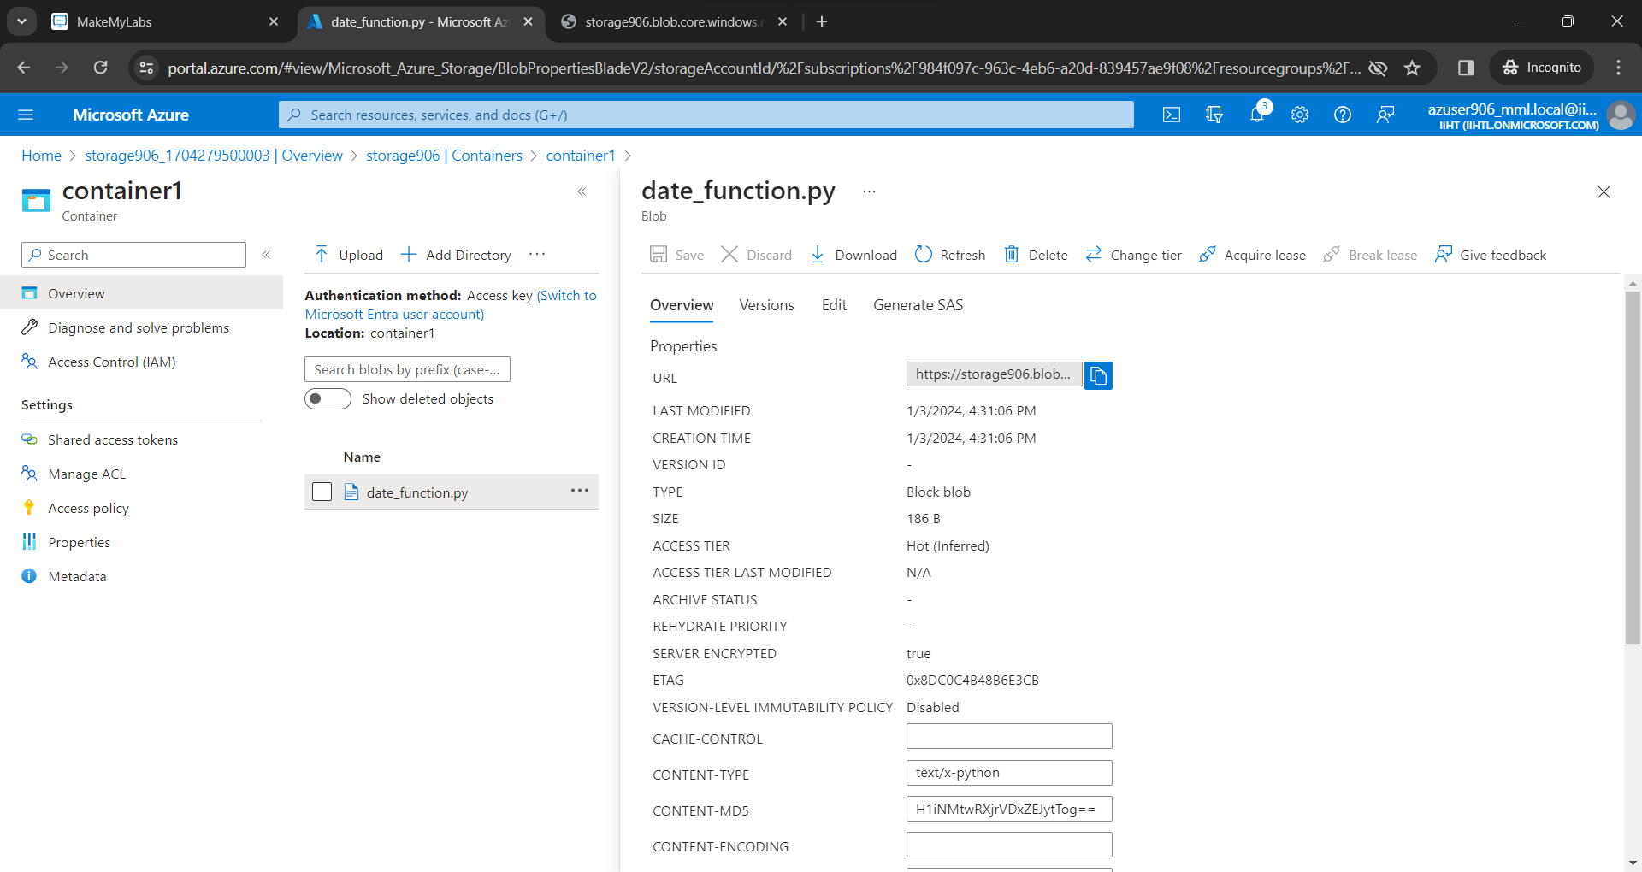

We have to download Microsoft azure storage explorer and there we should connect to our azure account

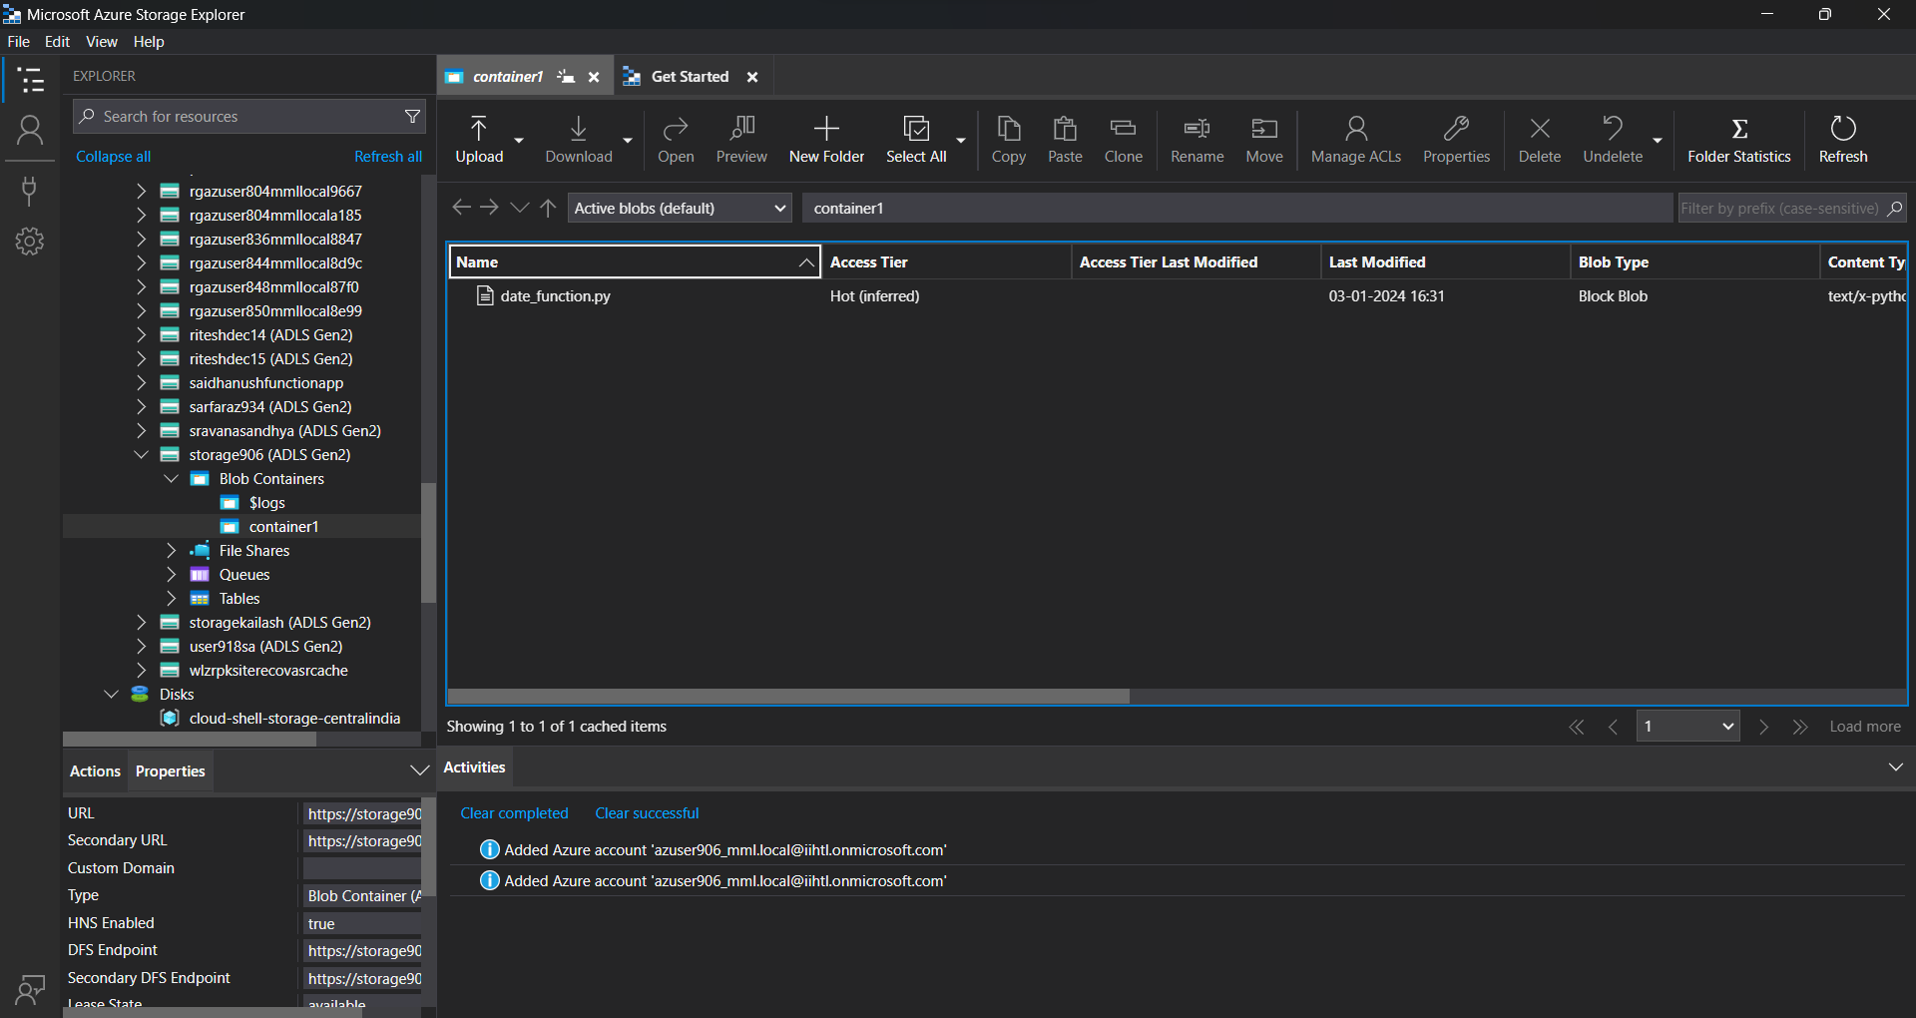

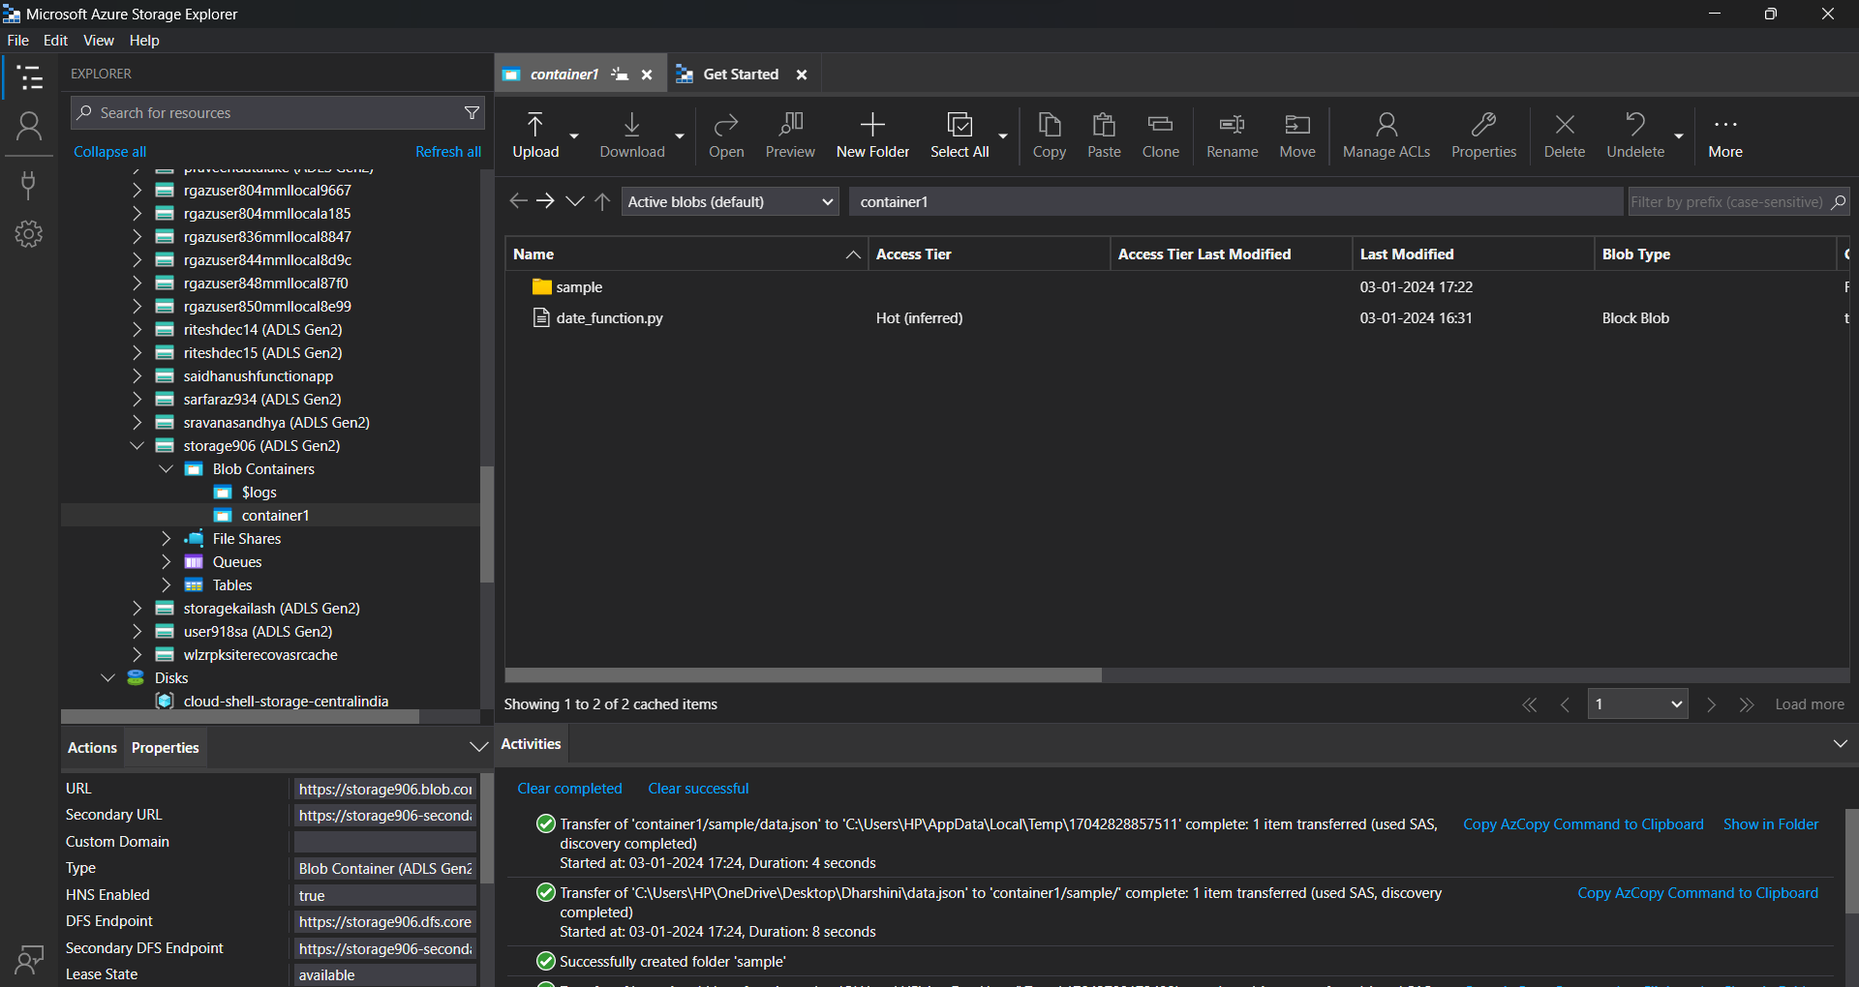

After connecting we can create new folders or upload files in the container from storage explorer

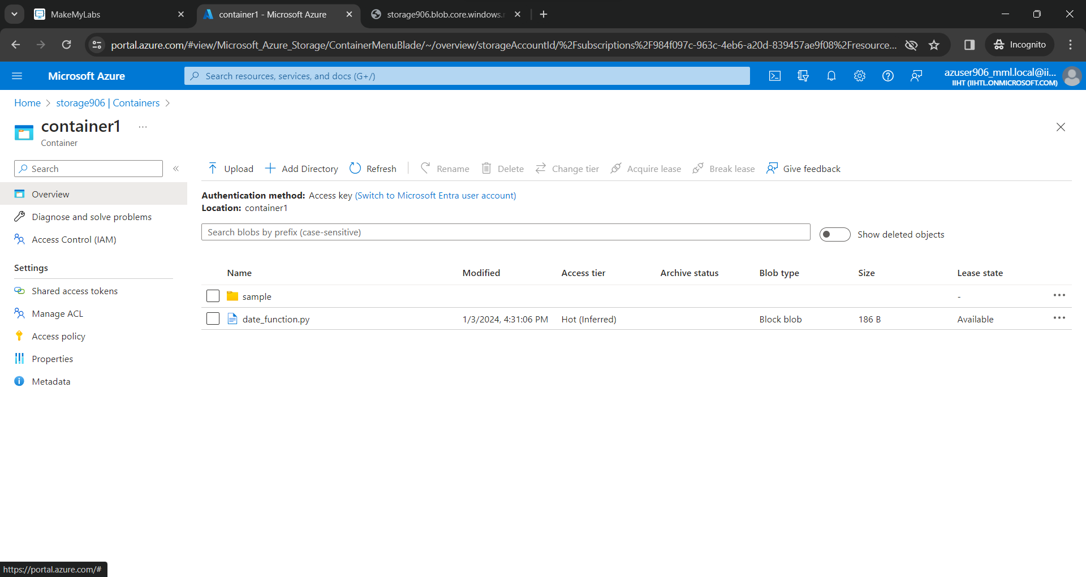

The files uploaded in storage explorer will be updated on our azure portal